Thinking of selling your home? Read this letter first.
"Can You Find The Mistake In The Ad Below That Cost The Seller $57,500?"
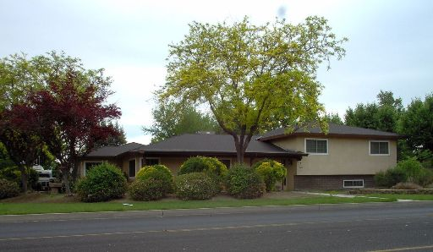
Beautiful home in Brookfield subdivision on large lot with incredible view. Lots of tile, large 3 car garage, wood burning stove in family room, screened porch with vinyl shutters, ceilings fans in all rooms. Absolutely first class property all the way. New roof 4/3. Newer HVAC(4 ton). Exterior painted with Duracoat. Newer aluminum garage door and garbage disposal. RE-plumbed w/CPVC.
For Sale
$450,000
4 Bedroom
2 Bathrooms
Call 555-1212
for more info
Why Did The Home Above Sell For $57,500
Less Than The Neighbors Home?
Two very similar homes recently sold. They were on the same street, seven doors down from each other. One sold for $422,500. The other sold for $480,000.
Both sellers hired a good Realtor. Both Realtors did a decent job at selling the home.
But, one Realtor made a mistake and this home sold for $57,500 less than an identical home 2 doors down.
Both homes were on the market for at least a month before selling. (So, we can't say the home was priced below market value.) Despite all this, one home sold for $57,500 more than the other. This seemingly innocent mistake is made every day all across America.
This same mistake could be made on your sale.
[Continued on Next Page.]
It could cost you $57,500!
I am sure you are thinking, "If this happens every day, then why doesn't anyone report it" The reality is that most sellers don't realize when it happens.
Here is how to find out why one home
sold for $57,500 less than the other...
And, discover how to avoid having this
happen on your home sale. Do this.
Email me at xxxx or call me at xxxx.

My software will automatically reply back to your cell phone with a link to the
information. That link will show why this home sold for $57,500 less.
Email me at xxxx or call me at xxxx.
At that link you will simply enter your name, address, and email address and be immediately directed to the information. You will find the answer at the bottom of the report.
Don't worry. I won't start hounding you with constant phone calls. I prefer to run my business a little differently. I know that if I provide enough value to the public, then my business will grow naturally.
In the meantime, if you have any real estate questions, then do not hesitate to send me an email at Name@Email.com
Well, that's it for me. Thank you for reading this letter. I wish you the best of luck with your home sale.

Your Name
Your Brokerage
Best Regards,
Your Name
Your Real Estate Company
Website: YourWebsite.com
Phone: (333) 555-1212
Email: Name@Email.com
(The picture and some of the details in the ad have been
changed to protect the identity of the people involved.)
Not intended to solicit any properties already listed for sale with another real estate agent.

The picture of the home and some of the details of the ad have been changed to protect the identity of the people involved. Not intended to solicit any properties already listed for sale with another real estate agent. If your home is already for sale, then please disregard this message.

